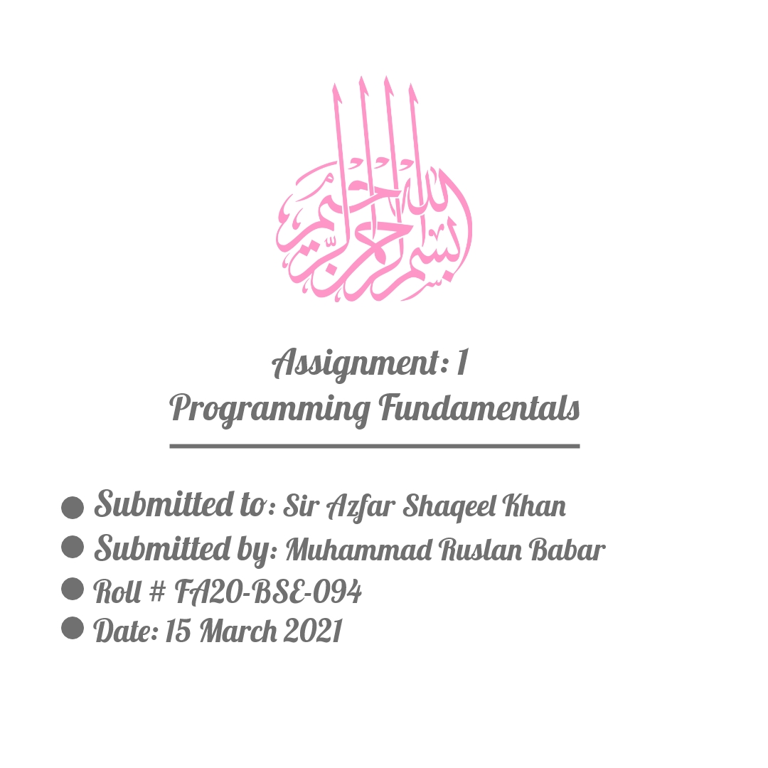

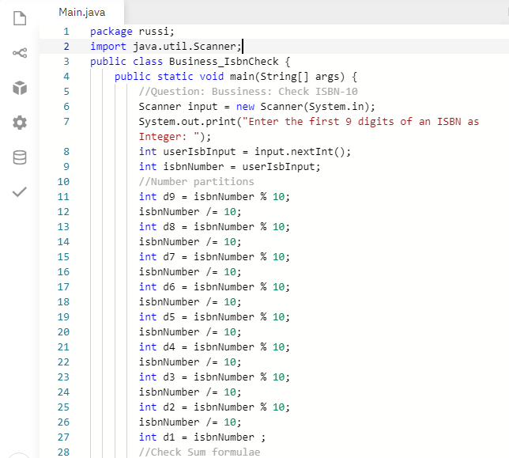

Question1: ***Business ISBN***

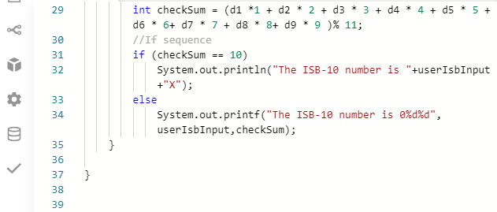

Question2: ***Game Lottery***

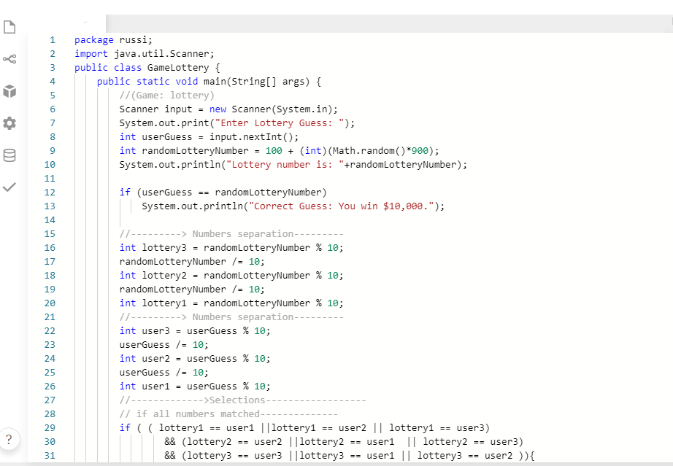

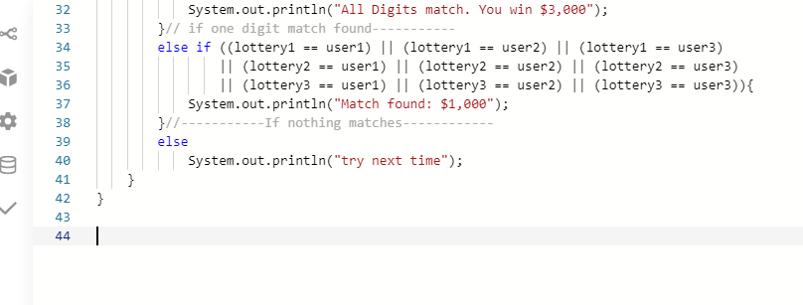

Question3: **Zeller’s Congruence**

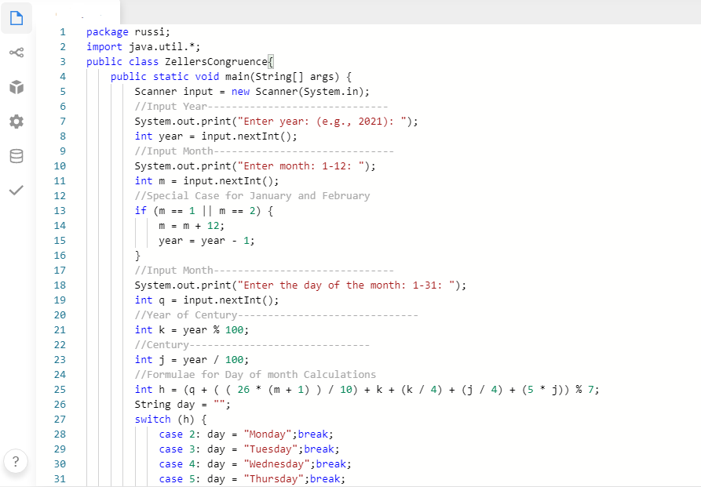

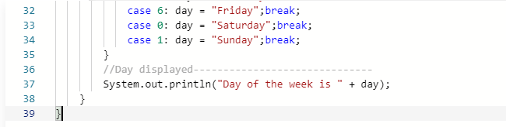

**Question1**: ***Business ISBN***

**OUTPUT**

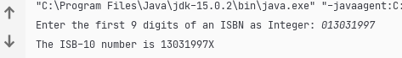

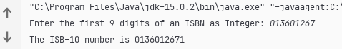

**Question2**: ***Game Lottery***

**OUTPUT**

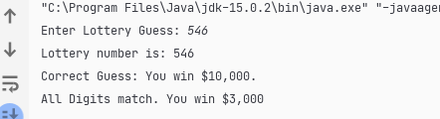

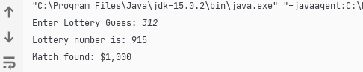

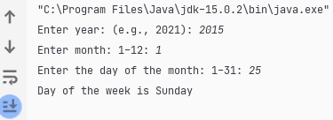

**Question3**: **Zeller’s Congruence**

**OUTPUT**